tCase: An Interactive Transparent Display

for Cultural Heritage Exhibitions

1st Author

1st author's affiliation  
1st line of address  
2nd line of address  
Telephone number, incl. country code

1st author's E-mail address

2nd Author

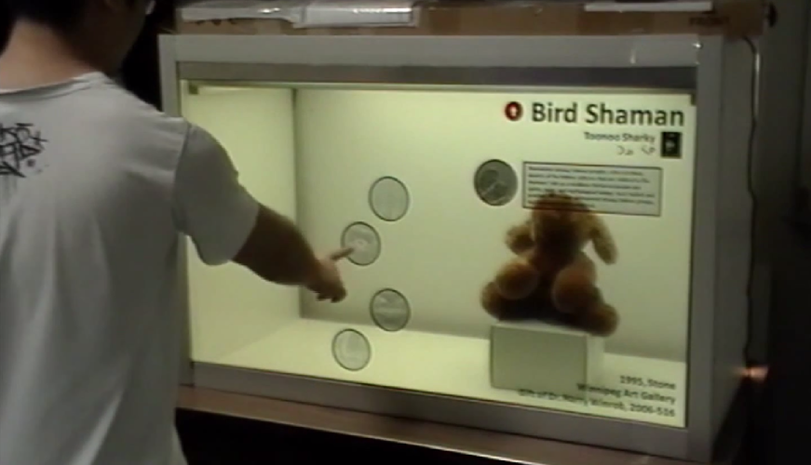

Figure 1: tCase containing a [ethic group] sculpture on display at the [city] Art Gallery.

2nd author's affiliation  
1st line of address  
2nd line of address  
Telephone number, incl. country code

2nd E-mail

3rd Author

3rd author's affiliation  
1st line of address  
2nd line of address  
Telephone number, incl. country code

3rd E-mail

**ABSTRACT**

We present the *tCase* – an interactive transparent exhibition case supporting the exploration of cultural heritage exhibits. The tCase encloses an exhibit (e.g. a small sculpture) and allows visitors to see it from all sides where three sides and the top are transparent acrylic and one side is an interactive transparent display. The tCase allows visitors to access information about the exhibit and other collocated objects, and to create ephemeral content to support collaborative exploration. In this paper we focus on the tCase’s design, and present three main contributions. First, based on observations, interviews and related research we highlight a set of challenges transparent displays face in public exhibition environments. Second, we describe our current tCase implementation, including the notion of information layers, interaction surrogates, and ephemeral annotations. Third, we present preliminary feedback from different stakeholders in the museum experience (artists, curators, and visitors) and present a design space definition for the design of interactive transparent-display exhibition cases.

**Categories and Subject Descriptors**

H5.2 [Information interfaces and presentation]: User Interfaces. - Graphical user interfaces.

**General Terms**

Design, Human Factors.

**Keywords**

Transparent Displays, Cultural Heritage, tCase, Exhibition, Transparent Case, Case Display, Museum Display

# INTRODUCTION

Transparent exhibition cases are essential media for the display of volumetric artifacts (e.g. sculptures, vases, etc) which, unlike paintings or photos, could be explored from multiple angles. Their usage in museums and galleries has the dual purpose to showcase and protect the exhibit. Attached labels provide basic information such as the exhibit’s name, author, origin, material and year. Thus, exhibition cases support a visiting experience where visitors explore and are informed, while preserving the exhibit’s safety.

The museum visiting experience is, nonetheless, evolving with the emergence of novel technologies. Capture technologies gather and consolidate information which was previously scattered around in books, reports and audios. Access technologies like audio guides, mobile apps and public displays present information when visitors are nearby the exhibit. The collocated information availability impacts the museum visiting experience significantly in different aspects including 1) improving access to information about the exhibition itself, the artist, the artist’s work, collection, artistic movement, and general community [REF], 2) personalizing content according to the visitor type [REF], 3) enabling groups of visitors to collaborate [REF], and 4) extending the visiting experience before and after the visit itself [REF].

Despite these benefits, field deployments show that current technological embodiments might not be optimal. Audio guides isolate people from the group making it harder to perform collaborative explorations. Public displays require space otherwise dedicated to artifacts, modify the exhibition layout and are spatially detached from the objects. Mobile devices take the attention away from the exhibition to the device.

Permission to make digital or hard copies of all or part of this work for personal or classroom use is granted without fee provided that copies are not made or distributed for profit or commercial advantage and that copies bear this notice and the full citation on the first page. To copy otherwise, or republish, to post on servers or to redistribute to lists, requires prior specific permission and/or a fee.

*Conference’10*, Month 1–2, 2010, City, State, Country.

Copyright 2010 ACM 1-58113-000-0/00/0010 …$15.00.

Our approach, rather than introducing a new embodiment, is to redesign a currently used medium: exhibition cases. In this paper we introduce the tCase, a transparent-display exhibition case supporting the information needs of museum visitors (see Figure 1). The tCase appropriates an existing exhibition media and augments it with interactive capabilities. Based on observations, interviews, museum studies, our experience designing the tCase, and initial feedback from involved stake holders (artists, curators, administration and visitors), we propose a design space for the design and development of similar interactive transparent-display exhibition cases that support the museum visiting experience.

# RELATED WORK [0.5P]

Paragraph about technologies for information access in museums, including audio guides, mobile devices and public displays.

Paragraph about direct information access focused mostly on augmented reality applications.

Paragraph about transparent displays covering interactions, applications and limitations.

# ARTIFACTS ON DISPLAY [1P]

First paragraph describing the goal and methods used. Say that we are going to present the requirements.

Requirement 1 – Information layers (object, local, etc). It’s not a public display where there is lots of content: it changes the usage of the system blocking access to the artefact.

Requirement 2 – All around visibility

Requirement 3 – Walk and use by multiple users.

Requirement 5 – facilitate collaborative exploration; serve as a common frame of reference, free exploration, playfulness

Requirement 4 – Attention and interaction blindness

To summarize, the hardware and interaction design of transparent display exhibition cases should fulfill the following requirements:

R1 –

R2 –

R3 –

R4 –

R5 –

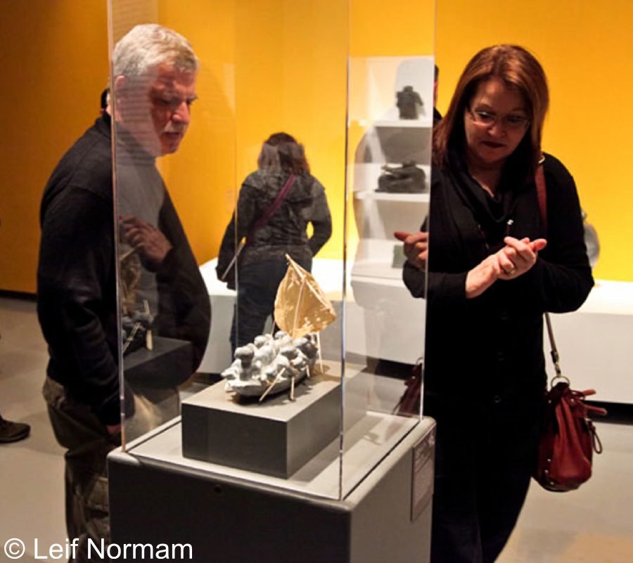

Figure 2: Acrylic exhibition case.

# SYSTEM OVERVIEW [3P]

## The tCase

## Information Layers

## Indirect Interactions

## Attention-aware Adaptations

## Ephemeral Annotations

# TECHNICAL IMPLEMENTATION

# PRELIMINARY FEEDBACK

# TRANSPARENT CASES DESIGN SPACE

Information layers: object, local, associated, external

# CONCLUSIONS

# ACKNOWLEDGMENTS

# REFERENCES

1. Bowman, M., Debray, S. K., and Peterson, L. L. 1993. Reasoning about naming systems. *ACM Trans. Program. Lang. Syst.* 15, 5 (Nov. 1993), 795-825. DOI= <http://doi.acm.org/10.1145/161468.16147>.

Columns on Last Page Should Be Made As Close As Possible to Equal Length